CST1340 – Information in Organisations Group Coursework Report
Student Name: Caleb Kinnah
Student ID: M01054278
Module Leader: Ariadne Tsiakara

Section 1 – HTML
HTML screenshot and home page
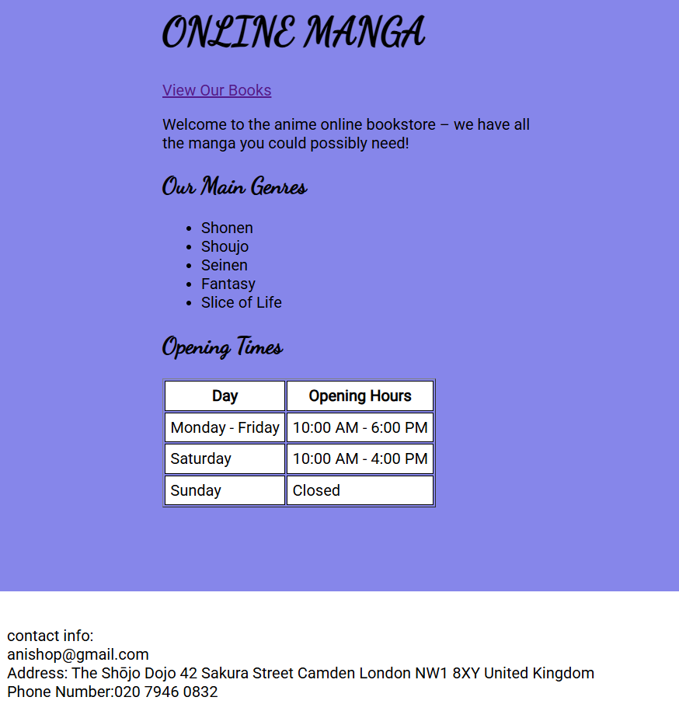
The main page displays the shop name “ONLINE MANGA” with a cursive font, a welcoming paragraph, a list of main genres from shonen to slice of life, and a table of opening hours.
The link “View Our Books” is at the top which takes the user to the next page. The footer is fixed at the bottom of the viewport, showing the shop’s email, address, and phone number. All content is centred within a white background container.
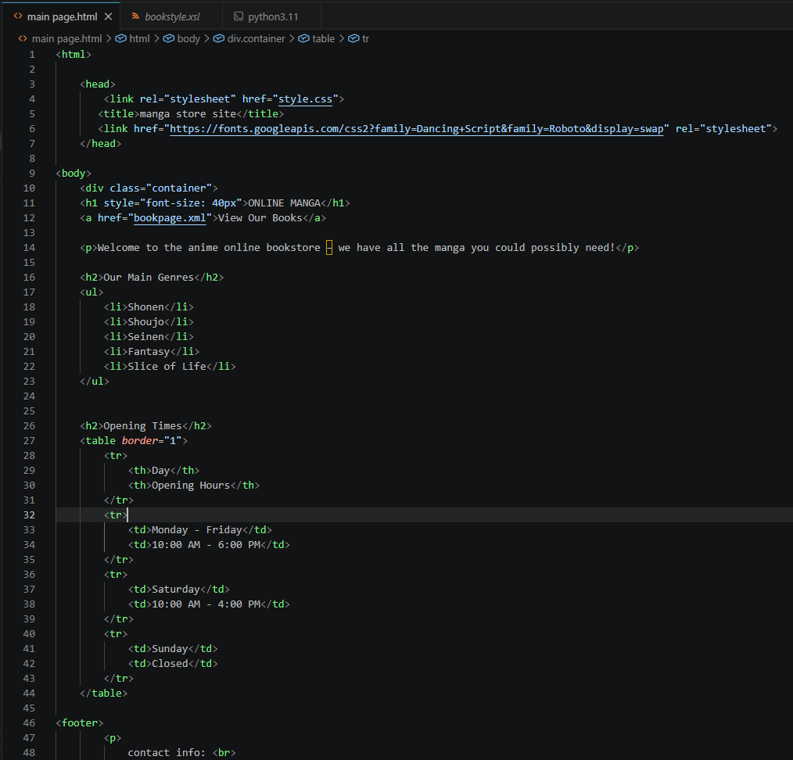
The HTML uses a <div class="container"> to wrap the main content. The opening hours are presented in a border="1" table.
The footer is a <footer> element containing contact details. A link <a href="bookpage.xml">View Our Books</a> provides navigation to the XML/XSL page. The page links to an external CSS file (style.css) and imports Google Fonts.
- screenshot of CSS codes.
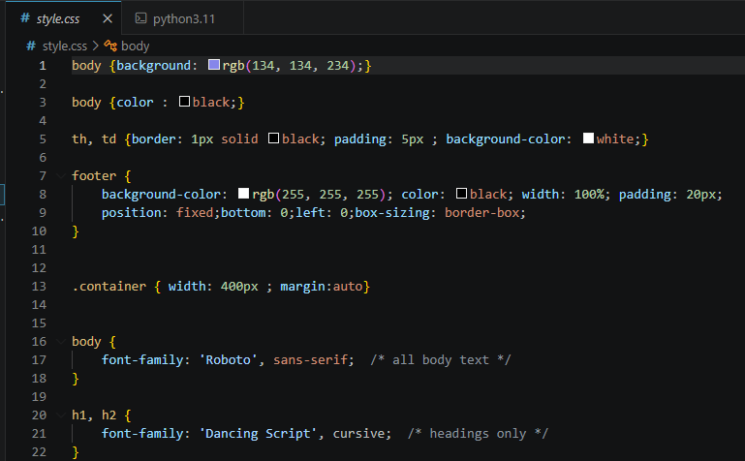
The CSS sets a soft purple background and applies the ‘Roboto’ font to body text and ‘Dancing Script’ to headings.
The container class has a fixed width of 400px and margin: auto to centre the content. The footer is styled to be fixed at the bottom of the page.

Section 2 – XML
The XML schema
The XML document (bookpage.xml) is validated against bookstore.dtd. The DTD defines the structure: the root element <bookstore> must contain one or more <book> elements. Each <book> must contain exactly six child elements in a strict
<title>, <author>, <genre>, <price>, <year>, <stock>. All of these are of type #PCDATA, they all contain parsed character data.
screenshot of the XML file.
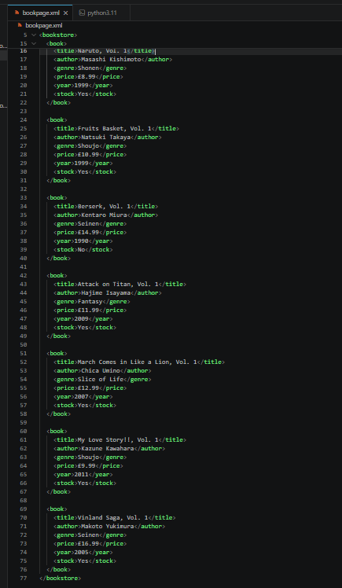

The XML file opens with the XML declaration, a DOCTYPE reference to bookstore.dtd, and a processing instruction linking the XSL stylesheet (bookstyle.xsl). The root <bookstore> contains eight <book> elements, each with descriptive tags. Sample entries include “One Piece, Vol. 1” (Shonen, in stock) and “Berserk, Vol. 1” (Seinen, out of stock).

Section 3 – Validation
screenshot of the DTD file
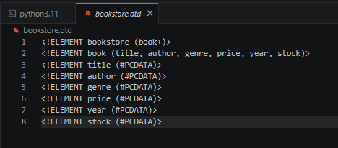
The DTD is written with <!ELEMENT> declarations. bookstore is defined as a container holding one or more book elements (book+). book is a container that holds six data elements in a specific sequence.
Each data element is declared as #PCDATA. No attributes or namespaces are required because the data is simple and the structure is enforced through element order. This ensures every book record is complete and correctly ordered.

Section 4 - Transformation
screenshots of the XSL/t file
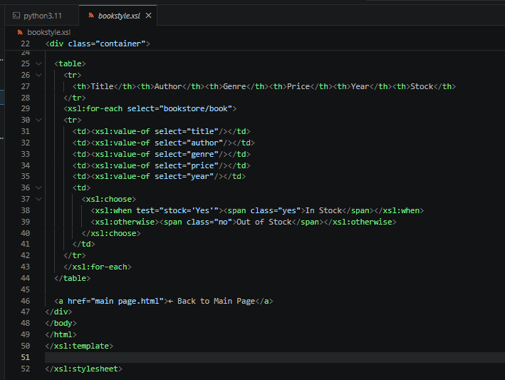

The XSL The stylesheet defines a template matching the root . It outputs an HTML page with embedded CSS.
An <xsl:for-each select="bookstore/book"> loop creates a table row for each book. Within each row, <xsl:value-of> extracts the data. The stock column uses <xsl:choose> to check the value of <stock>; if “Yes”, it shows “In Stock” in green (class yes), otherwise “Out of Stock” in red (class no). A link at the bottom (<a href="main page.html">) provides navigation back to the main page.

Section 5 – Author Contributions
Caleb Kinnah (M01054278):
I designed and coded the main HTML page (main page.html), including content structure and Google Fonts integration. Writing the CSS (style.css) making a consistent, responsive layout with a fixed footer. Created the XML data file (bookpage.xml) with eight manga entries covering various genres and stock statuses. Madde the DTD file (bookstore.dtd) to validate the XML structure and enforce data integrity. Developed the XSL file to format that converts data into a webpage table and highlights which stock is available or not. Implemented bidirectional navigation between the HTML page and the XML/XSL page. Tested the project locally using a Python HTTP server in VSC to resolve XSLT security restrictions in browsers, and compiled the final report and verifying all required files are included in the submission.

